SIMATS ENGINEERING
ASSESSMENT TOOL 2: Case Study

COURSE NAME: COMPUTER VISION COURSE CODE: ITA05

COURSE OUTCOME COVERED

CO3: Analyze and extract image features using detection and matching techniques for effective image representation and comparison. (BTL 4)

Assessment Tool Weightage: 20%

Read the given scenario carefully and analyze the problem using appropriate computer vision techniques. Justify your answers with relevant reasoning and comparisons wherever necessary.

12. Corner Detection in Textured Regions
A system applies corner detection in highly textured regions, resulting in excessive keypoints.
Analyze the issue and suggest methods to improve feature selection.

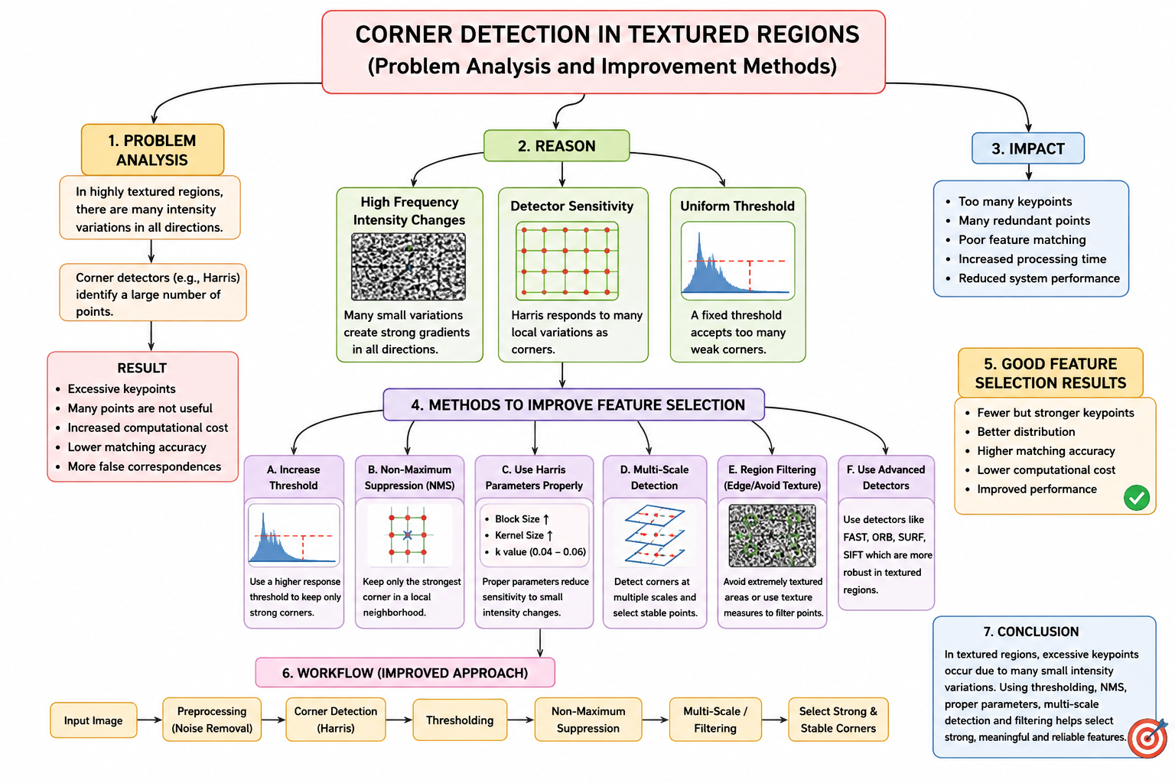
14. PCA and Information Loss
A system applies PCA aggressively and loses important feature details.
Analyze the trade-off between dimensionality reduction and information loss, and justify optimal component selection.

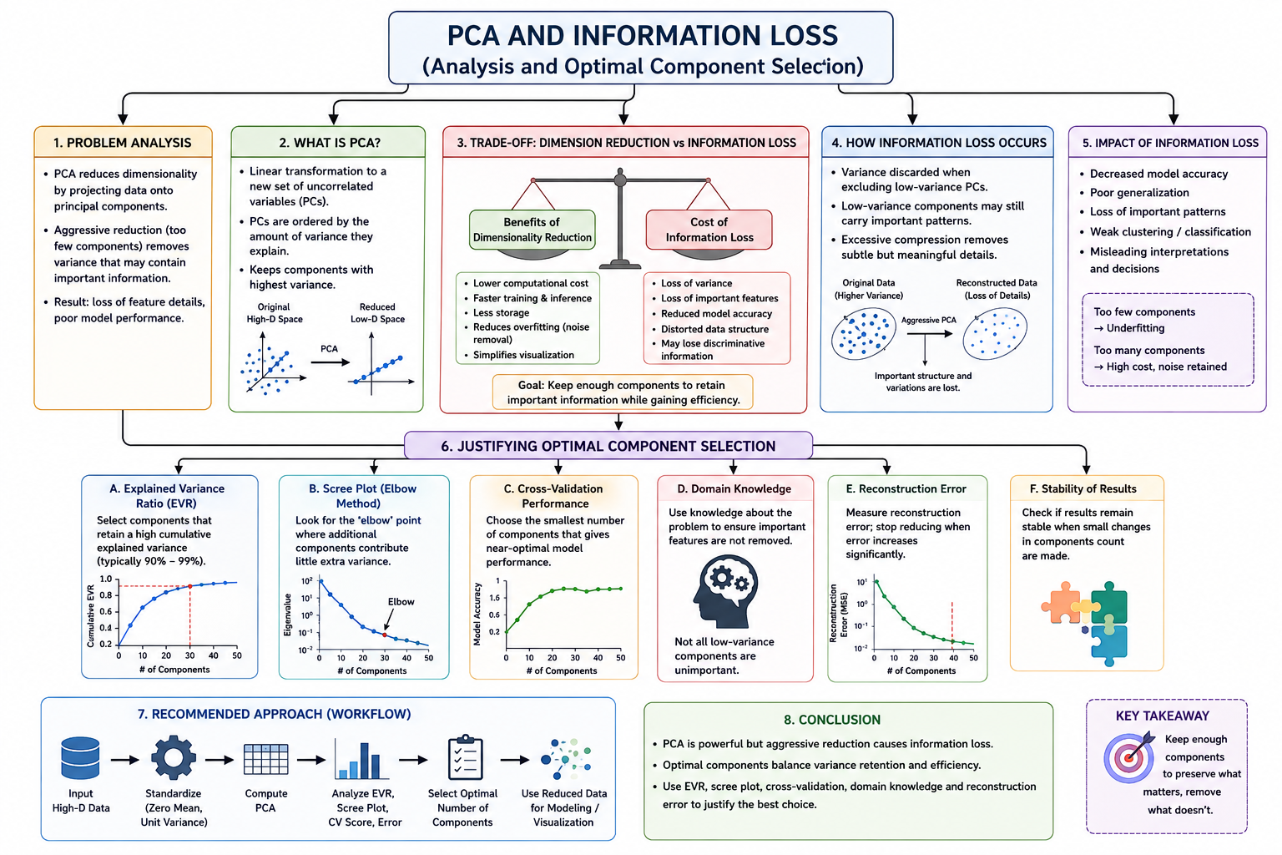

3. Hough Transform in Noisy Images
A system uses Hough Transform to detect lines in noisy images but produces inaccurate results.
Analyze the effect of noise on detection and suggest improvements based on preprocessing or parameter selection.

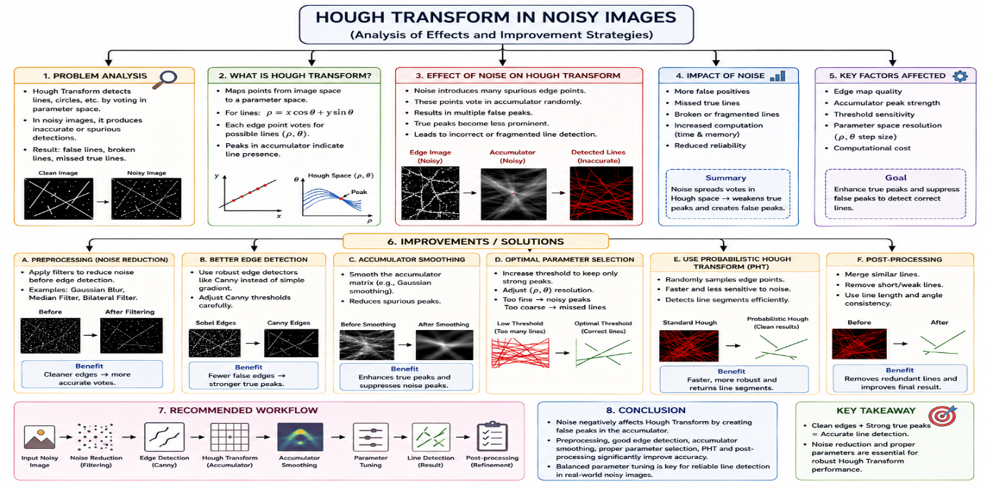

4. Feature Matching under Transformations
Two images of the same object are taken at different scales and orientations. Traditional feature matching fails, but scale invariant feature matching works effectively.
Analyze why scale invariant methods perform better in this scenario.
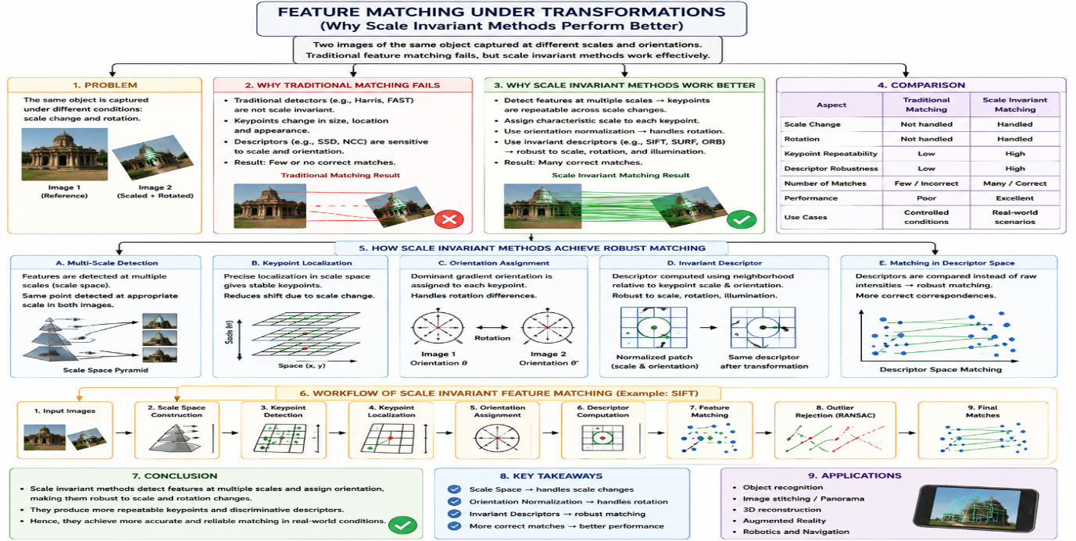

3. Hough Transform in Noisy Images
A system uses Hough Transform to detect lines in noisy images but produces inaccurate results.
Analyze the effect of noise on detection and suggest improvements based on preprocessing or parameter selection.
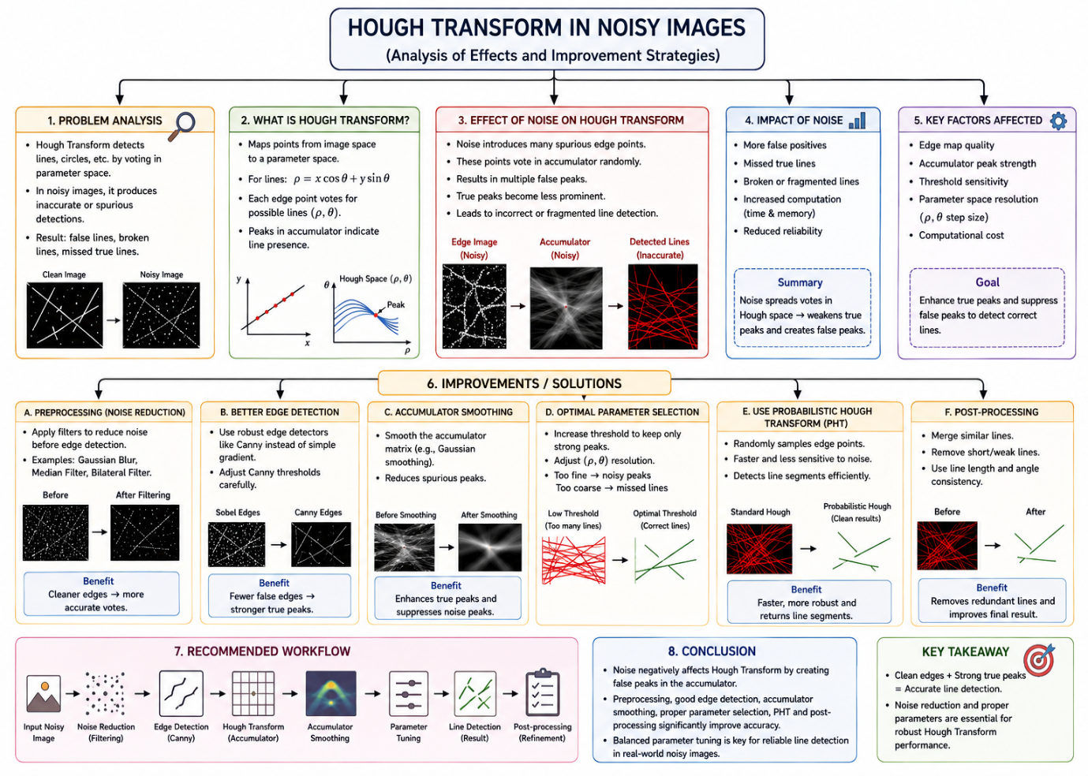

Code of Conduct:

I R.SRIVIDYA(192472261) (Name / Reg No) certify that this submission is my original work and that I have adhered to the guidelines specified for this assessment.
I understand that any violation of academic integrity rules will result in disciplinary action.
Srividya
Signature of the student:

RUBRICS FOR CALCULATION:

Criteria | Weightage | Level 4 – Exemplary | Level 3 – Proficient | Level 2 – Developing | Level 1 – Beginning
Understanding of Case | 25 | Thorough understanding; clearly identifies all key issues | Good understanding with most issues identified | Basic understanding; some issues missed | Poor understanding; problem not identified correctly
Application of Concepts | 25 | Effectively applies relevant concepts to analyze the case deeply | Applies appropriate concepts with minor gaps | Limited application of concepts | Fails to apply relevant concepts
Analysis | 20 | In-depth analysis with strong reasoning and insights | Good analysis with logical reasoning | Basic analysis with limited depth | Weak or no analysis; lacks reasoning
Solution Design | 20 | Innovative, feasible solutions with strong justification | Logical solutions with adequate justification | Basic solutions with weak justification | Incorrect or no solution provided
Clarity | 10 | Clear, well-structured, and easy to understand | Organized and understandable presentation | Limited clarity and structure | Poor clarity; difficult to understand

